DAR Akeem EMPLOYMENT APPLICATION FORM

Name: | NGUYEN THI NGOC CHI |  |  | Age: |  | 39
Address: | HAU GIANG PROVINCE |  |  | Mobile No: |  | 0366680377
BENEFICIARIES OR NEXT OF KIN
NAME |  | ADDRESS |  |  | CONTACT NO.
LE THI QUYEN |  | HAU GIANG PROVINCE |  |  | 0325997909
RELIGION | HEIGHT | WEIGHT | POSITION APPLIED |  | HOUSEMAID
NO | 158cm | 59kg | Monthly Salary |  | 1500 Riyal |  | اﻟﺮاﺗﺐ اﻟﺸﻬﺮي
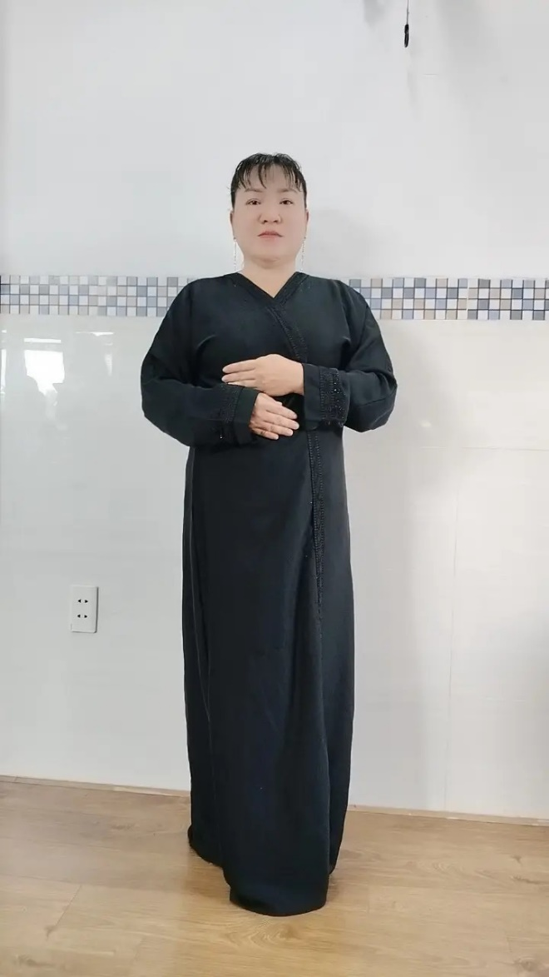 |  |  | Contract Period |  | 2 years |  | ﻣﺪة اﻟﻌﻘﺪ
 |  |  | Passport No. |  |  |  | رﻗﻢ ﺟﻮاز اﻟﺴﻔﺮ
 |  |  | Details of Application
 |  |  | Nationality |  | VIETNAM |  | اﻟﺠﻨﺴﻴﺔ
 |  |  | Complete Address |  | HAU GIANG PROVINCE |  | ﻣﻜﺎن اﻟﺴﻜﻦ
 |  |  | Date of Birth |  | 11 JULY 1985 |  | ﺗﺎرﻳﺦ اﻟﻤﻴﻼد
 |  |  | Place of Birth |  | HAU GIANG PROVINCE |  | ﻣﻜﺎن اﻟﻤﻴﻼد
 |  |  | Marital status |  | DIVORCED |  | اﻟﺤﺎﻟﺔ اﻻﺟﺘﻤﺎﻋﻴﺔ
 |  |  | No. of Children |  | 2 |  | ﻋﺪد اﻷﻃﻔﺎل
 |  |  | اﻟﻠﻐﺔ واﻟﺘﻌﻠﻴﻢ Education & Languages
 |  |  | English |  |  |  | اﻻﻧﺠﻠﻴﺰﻳﺔ
 |  |  | Arabic |  | Little |  | اﻟﻌﺮﺑﻴﺔ
 |  |  | Education |  | NO |  | اﻟﻤﺴﺘﻮى اﻟﺘﻌﻠﻴﻤﻲ
 |  |  | ﺧﺒﺮة ﺧﺎرج اﻟﺒﻼد Abroad Employment Previous
 |  |  | Period |  | Position |  | City, Country
 |  |  | 2015-2024 |  | Housemaid |  | Vietnam

