DAR Akeem EMPLOYMENT APPLICATION FORM

Name: | LY THI XUAN |  |  | Age: |  | 44
Address: | DONG NAI PROVINCE |  |  | Mobile No: |  | 0941285125
BENEFICIARIES OR NEXT OF KIN
NAME |  | ADDRESS |  |  | CONTACT NO.
LY THI THU |  | SOC TRANG PROVINCE |  |  | 0331253154
RELIGION | HEIGHT | WEIGHT | POSITION APPLIED |  | HOUSEMAID
NO | 156cm | 58kg | Monthly Salary |  | 1000 Riyal |  | اﻟﺮاﺗﺐ اﻟﺸﻬﺮي
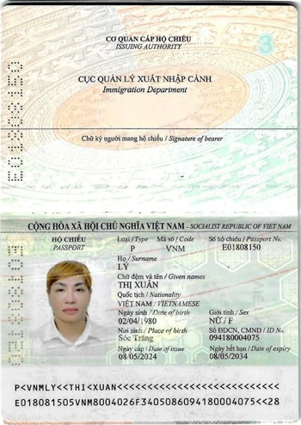 |  |  | Contract Period |  | 2 years |  | ﻣﺪة اﻟﻌﻘﺪ
 |  |  | Passport No. |  | E01808150 |  | رﻗﻢ ﺟﻮاز اﻟﺴﻔﺮ
 |  |  | Details of Application
 |  |  | Nationality |  | VIETNAM |  | اﻟﺠﻨﺴﻴﺔ
 |  |  | Complete Address |  | DONG NAI PROVINCE |  | ﻣﻜﺎن اﻟﺴﻜﻦ
 |  |  | Date of Birth |  | 02 JULY 1980 |  | ﺗﺎرﻳﺦ اﻟﻤﻴﻼد
 |  |  | Place of Birth |  | DONG NAI PROVINCE |  | ﻣﻜﺎن اﻟﻤﻴﻼد
 |  |  | Marital status |  | MARRIED |  | اﻟﺤﺎﻟﺔ اﻻﺟﺘﻤﺎﻋﻴﺔ
 |  |  | No. of Children |  | 2 |  | ﻋﺪد اﻷﻃﻔﺎل
 |  |  | اﻟﻠﻐﺔ واﻟﺘﻌﻠﻴﻢ Education & Languages
 |  |  | English |  | Little |  | اﻻﻧﺠﻠﻴﺰﻳﺔ
 |  |  | Arabic |  | Little |  | اﻟﻌﺮﺑﻴﺔ
 |  |  | Education |  | NO |  | اﻟﻤﺴﺘﻮى اﻟﺘﻌﻠﻴﻤﻲ
 |  |  | ﺧﺒﺮة ﺧﺎرج اﻟﺒﻼد Abroad Employment Previous
 |  |  | Period |  | Position |  | City, Country
 |  |  | 2015-2020 |  | Housemaids |  | Vietnam

