DAR Akeem EMPLOYMENT APPLICATION FORM

Name: | DINH THI NGOC GAM |  |  | Age: |  | 45
Address: | BINH DUONG PROVINCE |  |  | Mobile No: |  | 03945983125
BENEFICIARIES OR NEXT OF KIN
NAME |  | ADDRESS |  |  | CONTACT NO.
DINH THI NGOC GAM |  | BEN TRE PROVINCE |  |  | 0987213504
RELIGION | HEIGHT | WEIGHT | POSITION APPLIED |  | HOUSEMAID
NO | 152cm | 54kg | Monthly Salary |  | 1000 Riyal |  | اﻟﺮاﺗﺐ اﻟﺸﻬﺮي
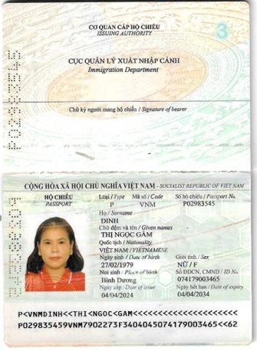 |  |  | Contract Period |  | 2 years |  | ﻣﺪة اﻟﻌﻘﺪ
 |  |  | Passport No. |  | P02983545 |  | رﻗﻢ ﺟﻮاز اﻟﺴﻔﺮ
 |  |  | Details of Application
 |  |  | Nationality |  | VIETNAM |  | اﻟﺠﻨﺴﻴﺔ
 |  |  | Complete Address |  | BINH DUONG PROVINCE |  | ﻣﻜﺎن اﻟﺴﻜﻦ
 |  |  | Date of Birth |  | 27 JULY 1979 |  | ﺗﺎرﻳﺦ اﻟﻤﻴﻼد
 |  |  | Place of Birth |  | BINH DUONG PROVINCE |  | ﻣﻜﺎن اﻟﻤﻴﻼد
 |  |  | Marital status |  | MARRIED |  | اﻟﺤﺎﻟﺔ اﻻﺟﺘﻤﺎﻋﻴﺔ
 |  |  | No. of Children |  | 3 |  | ﻋﺪد اﻷﻃﻔﺎل
 |  |  | اﻟﻠﻐﺔ واﻟﺘﻌﻠﻴﻢ Education & Languages
 |  |  | English |  | Little |  | اﻻﻧﺠﻠﻴﺰﻳﺔ
 |  |  | Arabic |  | Little |  | اﻟﻌﺮﺑﻴﺔ
 |  |  | Education |  | NO |  | اﻟﻤﺴﺘﻮى اﻟﺘﻌﻠﻴﻤﻲ
 |  |  | ﺧﺒﺮة ﺧﺎرج اﻟﺒﻼد Abroad Employment Previous
 |  |  | Period |  | Position |  | City, Country
 |  |  | 2019-2023 |  | Housemaid |  | Vietnam

